Cooperation Agreement
Table of Contents
Strikes and warnings 1
Evaluation system 1
Illness and personal problems 1
Late and poor quality work 2
Arguing and disagreements 2
Availability and communication 2
Scrum and deadlines 2
Backup procedures 2
Sharing important files 2
Primary team objectives 3
Contact information 3
Signatures 4

This cooperation agreement is effective immediately after being signed and will be dissolved when the cooperation between the group members is no longer necessary. The agreement will bind the parties to the terms and conditions stated below. This is a living document and so are its deliverables. Hence, the deliverables belong to the parties who have signed the document and are bound to copyrights for indefinite period.

Strikes and warnings
For this project we will be using a strike and warning system. When a member obtains three strikes he or she will be kicked from the group. There will not be made any exceptions. For some violations a warning will be given. Two warnings will result in one strike. All members should be informed when a strike is given. The reason for the strike should be given as well and it should be written down in an online version of this cooperation agreement to count.

Evaluation system
In this period we will be using an evaluation system as well. In this system the group members will be giving each other grades on a scale from one to four on certain aspects of cooperation. This will be done on a weekly basis and the grades should be sent in before 12:00 PM on every Sunday.
For each member we will calculate the average grade. If this grade turns out to be lower than 2.45 he or she will get a strike.
- When your grade of the week is lower than 2.45 you will get a strike;
- If you do not sent in your grades before 12:00 PM on every Sunday you will get a warning.

Illness and personal problems
- When one of the members is ill he or she will have to notify the other group members;
- When the illness makes it impossible for the concerning member to deliver his or her work on time it will be the task of the other members to make sure the work will still be delivered before the deadline. Do the ill members turn out to have done nothing for their task, then the deadline can be postponed;
- When a team member has personal problems (e.g. the death of a family member), he or she should inform the other parties and when needed, the other parties will have to take over the work of the member who has the personal issues. Again if this member turns out to have done nothing for his or her task yet, the deadline can be postponed.

Late and poor quality work
- When a member fails to deliver his or her work before the set deadlines, he or she will be given an instant strike;
- When a member delivers poor quality work, he or she will have to remake this task and improve his or her work before the new deadline;
- When a member fails to deliver good quality work after the second deadline, he or she will be given an instant strike.

Arguing and disagreements
- When two or more members have a disagreement, it should be solved by voting. The “losing” party will have to cope with the decision made;
- When cooperation is difficult due to two or more members arguing and it cannot be settled by the other members, there will be called in another independent party to mediate. The project coach is the primary candidate for the mediation.

Availability and communication
- The members must be available at any given time to work on the project. Of course, deliberation is needed to decide on a certain time. However all parties must understand that Hanze is priority number one and that all the members depend on each other;
- When one of the members shows more than 10 minutes late than the set time he or she will get a warning. Two warnings mean that this member will be given a strike. Delay caused by public transport is excused;
- When a member receive a message through any communication tool, he or she is obliged to reply to this message as long as it is meant for this particular member. Failing to communicate effectively will result into a warning. This warning will count towards the strike count as well.

Scrum and deadlines
For this project we will use a scrum tool called Trello. You can find it at Trello.com. The Trello application is available for download as well.
- Every team member must have a Trello account;
- Every team member has to make sure his or her tasks are up to date;
- When a team member is confused about something that has to do with Trello, he or she has to actively ask around and try to find out what is going on;
- All deadlines in Trello will be set in consultation with the other members;
- All set deadlines in Trello cannot be changed when there are five days left before the deadline.

Backup procedures
- When a file is in “work-in-progress” stage, it should be constantly backed up upon the progress of that file;
- Backing up will be done via cloud storing services (Such as Google Drive, Dropbox etc.);
- When a file is in its final form, it should be backed up both on cloud storing services and via personal means (USB sticks or external HDD);
- If a file gets lost, the person that was in charge of it has to remake it, without receiving additional work time. If the person fails to deliver it on time, he or she will be given a strike.

Sharing important files
- When a file is important for a deadline it should be sent to everyone over mail;
- Important files may never be sent over Skype alone;
- When a file is not sent by mail before the deadline you will get a strike (even though you might have sent it over Skype).

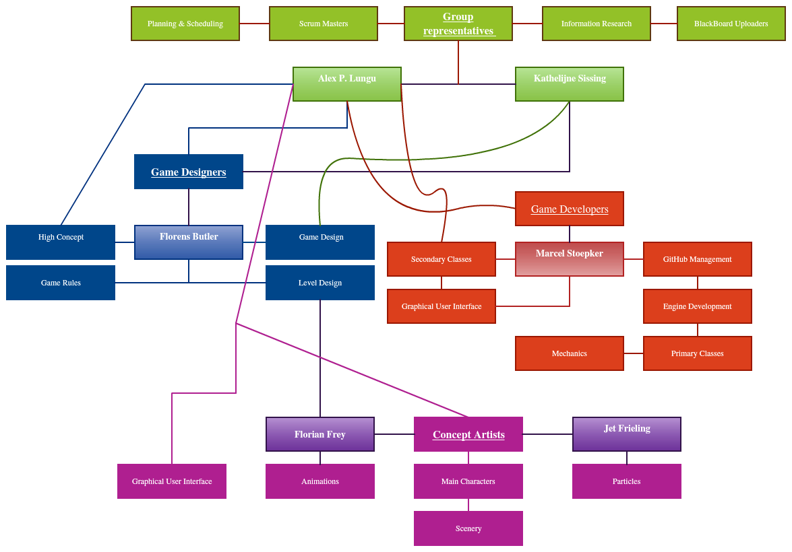
Primary team objectives
The diagram above displays general tasks. Dividing of the upcoming objectives will be decided with the team members' common agreement.

Contact information

Name | E-mail | Skype name | Phone number | Trello name
Kathelijne Sissing | Kathelijne.sissing@telfort.nl | Kathelijne-Sissing | +31 618545311 | KathelijneSissing
Alex Lungu | Lungualexandru1995@gmail.com | yourelofriends | +40 725 570 901 | alexandrulungu2
Marcel Stoepker | m.stoepker@st.hanze.nl | Marcel.stoepker | none | Legend ely
Jet Frieling | jet.frieling@live.nl | jet.frieling | +31615588502 | Jet Frieling
Florens Buter | florens8@hotmail.com | florens.buter | 06-57801979 | florensbuter
Florian Frey | Fgj.frey@gmail.com | bekennenderheide | +49 176 31234402 | Florianfrey1

Signatures
I have read the cooperation agreement and accept its terms and conditions entirely.
Alex Lungu:
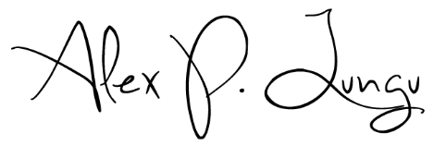

Kathelijne Sissing:


Marcel Stoepker:

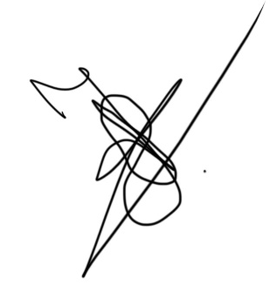
Jet Frieling:

Florens Buter:


Florian Frey:

Date: 9th of February 2016

